Pass the Pigs
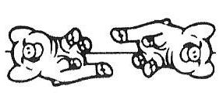 | Pig Out - Worth 0 tricks and end of turn. Pigs are on their sides. One dot is up and one dot is down. You keep all the points earned that turn |  | 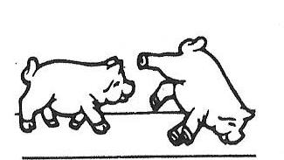 | Mixed Combo - Both pigs are doing tricks. Add the tricks from each pig and keep playing.
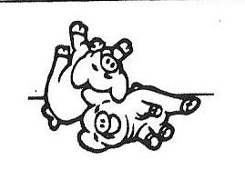 | Makin' Bacon - Worth 0 tricks and end of turn. Pigs are touching each other. Your turn is over and you get 0 tricks/points for that turn. |  | 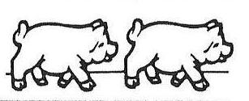 | Double Hoofer - Both pigs are doing the hoofer trick. Since synchronized tricks are more difficult, this is worth 4 tricks. Keep playing.
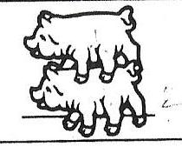 | Piggy Back - Worth 0 tricks and end of turn. Pigs are "piggy back" which is an unnatural position for pigs. Your turn is over and your entire score is back to 0. |  | 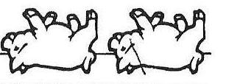 | Double Razorback - Both pigs are doing the razorback trick. Since synchronized tricks are more difficult, this is worth 4 tricks. Keep playing.
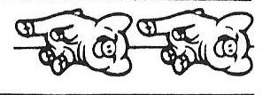 | Sider - Worth 1 trick and you keep playing. Both pigs are on their sides. Both dots up or both dots down. |  | 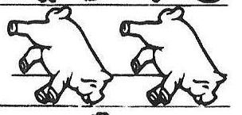 | Double Snouter - Both pigs are doing the snouter trick. Since synchronized tricks are more difficult, this is worth 8 tricks. Keep playing.
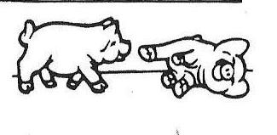 | Hoofer - Worth 1 trick and you keep playing. One pig is standing on its feet. |  | 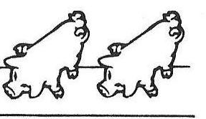 | Double Leaning Jowler - Both pigs are doing the leaning jowler trick. Since synchronized tricks are more difficult, this is worth 12 tricks. Keep playing.
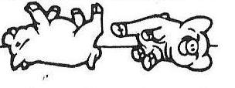 | Razorback - Worth 1 trick and you keep playing. One pig is lying on its back.
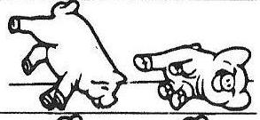 | Snouter - Worth 2 tricks and you keep playing. One pig is balancing on its nose and front feet.
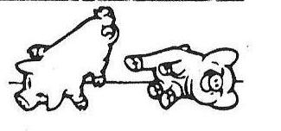 | Leaning Jowler - Worth 3 tricks and you keep playing. One pig is balancing on its nose, ear and one foot.

